**Record or Upload Media to Kaltura**

To start your recording, please click on “My Media” on SMU Homepage or “My Media” in Tools on your Course Homepage

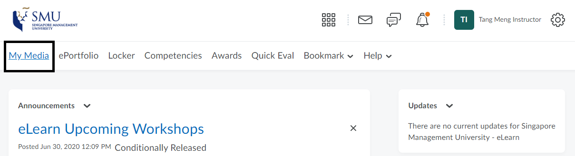

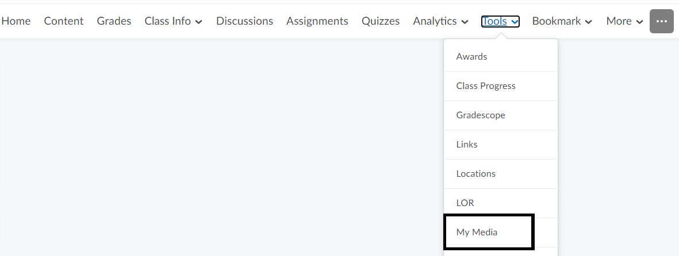

Kaltura – My Media (It will list all the media available to you, and you can record/upload new media from here

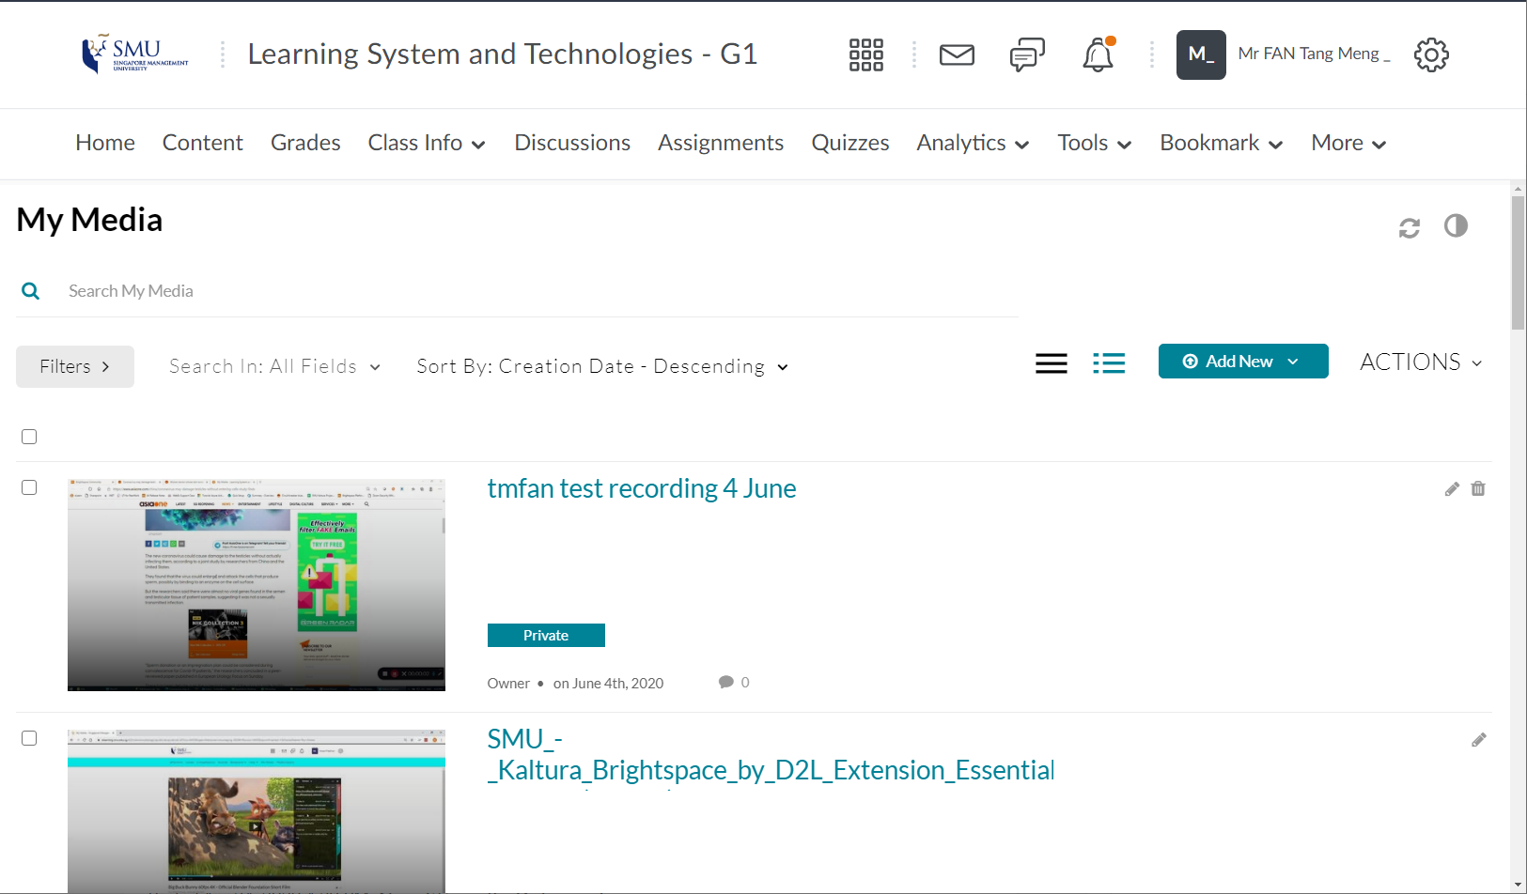

Launch Kaltura Capture to record the screens or if you already have an existing media, please click on “Media Upload”.

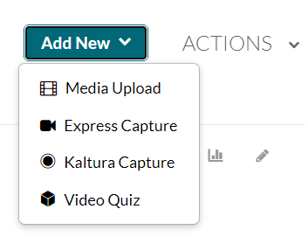

Kaltura Capture: Select what to record and click the red button.

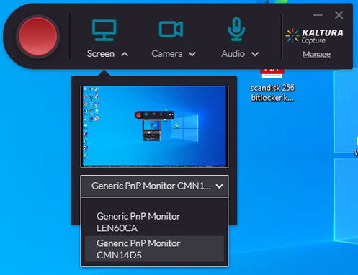

Media Upload: Select the file you want to upload. Enter media information, and click Save

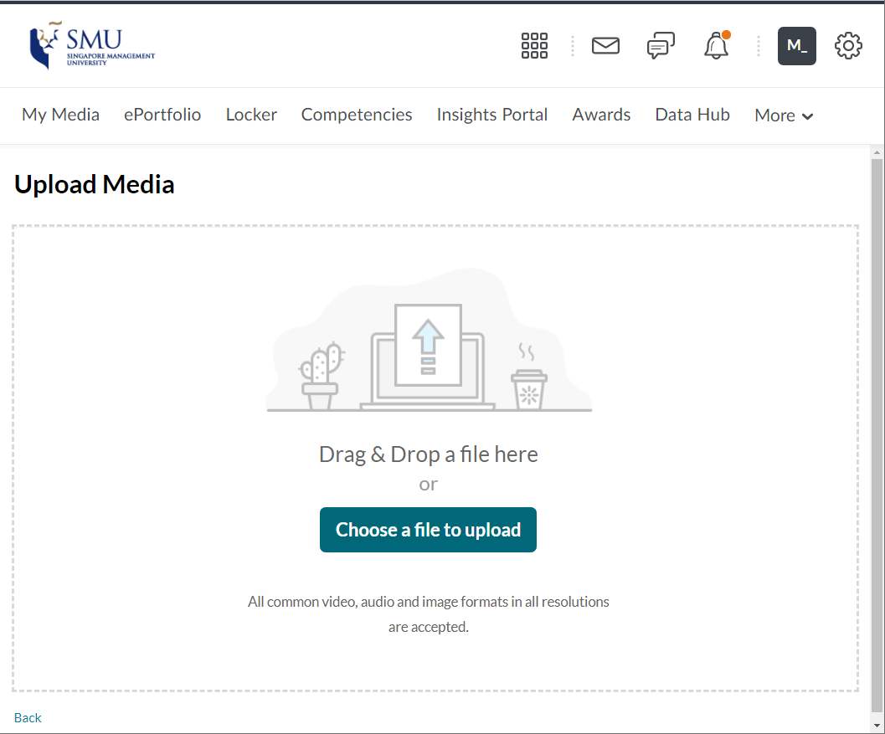

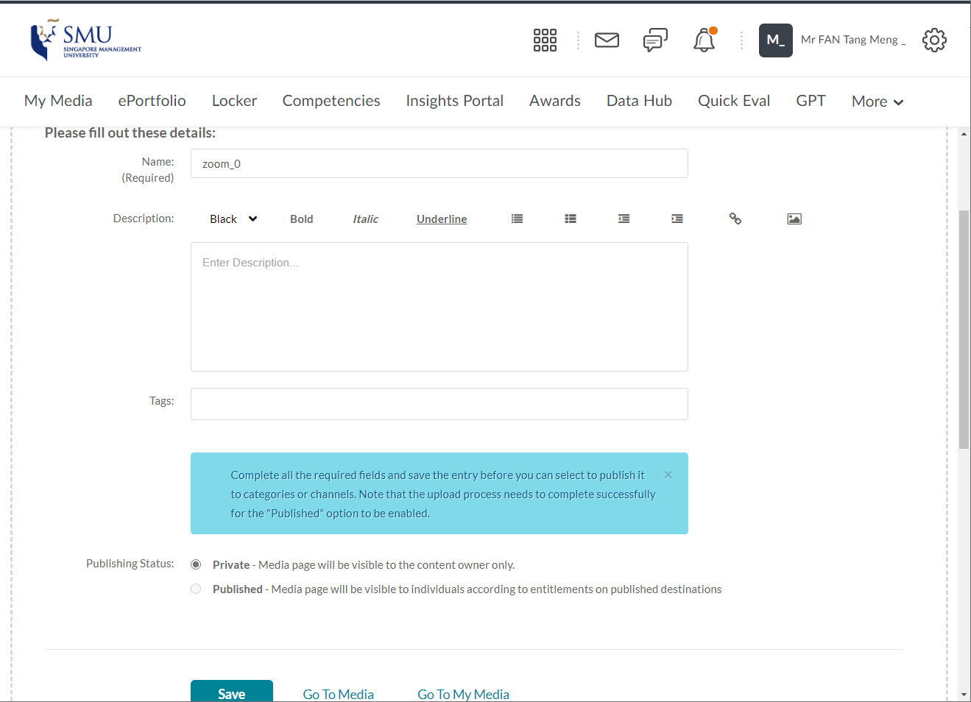

**Adding Content to eLearn**

Go to Content 🡪 Existing Activities 🡪 Add Media 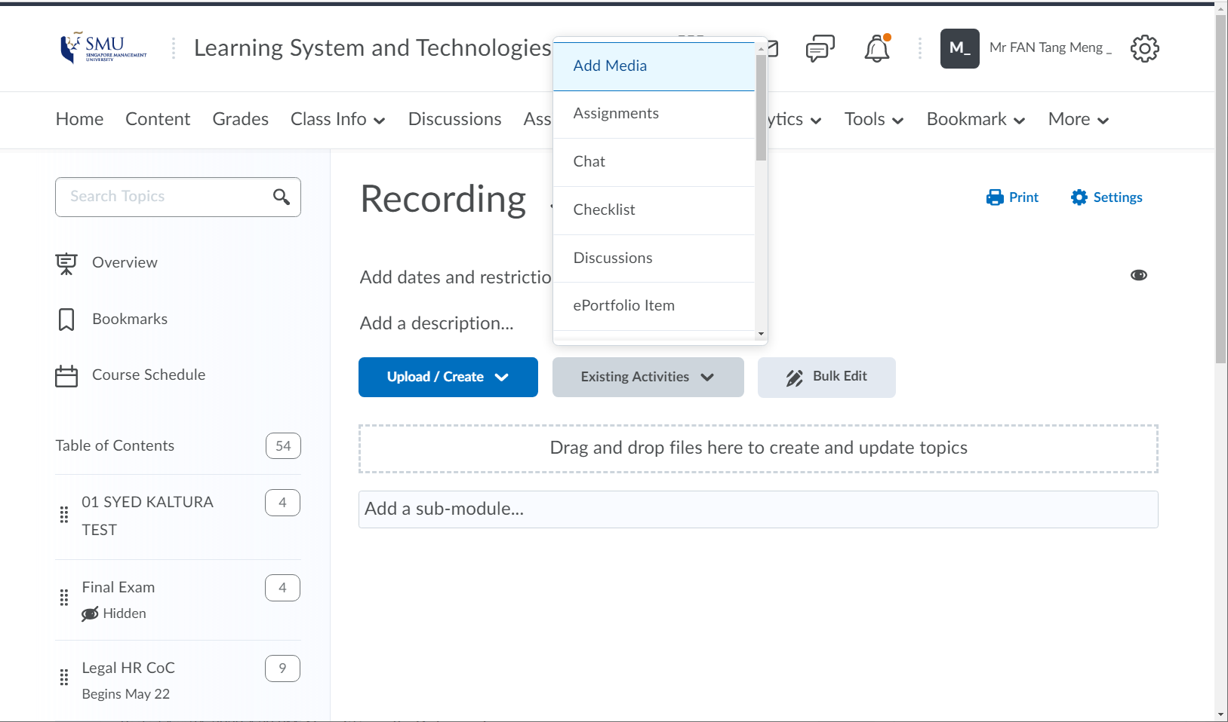

Select the media and click embed

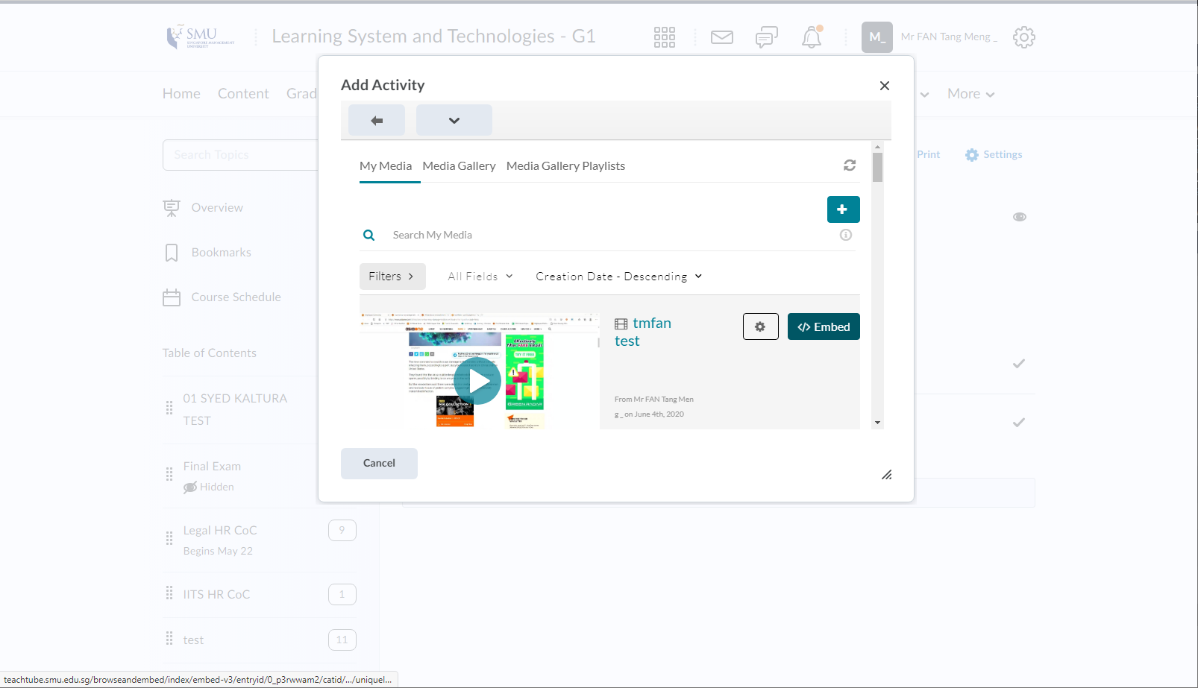

Embedded and click on the link to play video

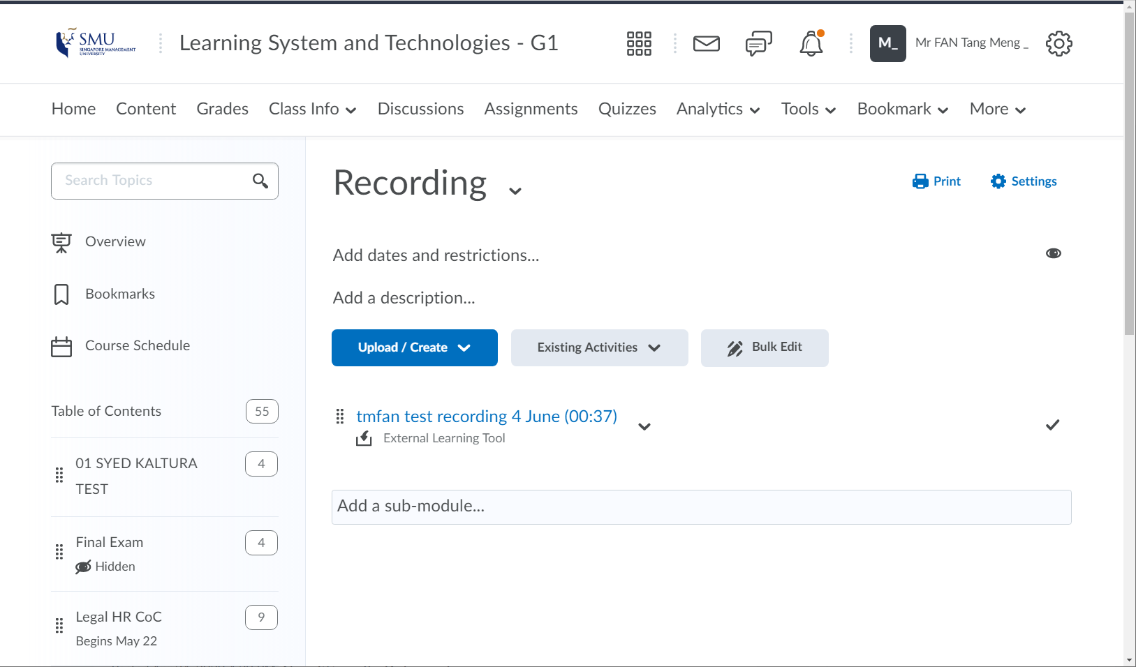

For more information on how to use Kaltura/Mediacast outside eLearn, please visit the link below.

<https://mediacast.smu.edu.sg/channel/Mediacast%2BUser%2BGuide/102363812>